AI Use Declaration Form
Course: Introduction to Artificial Intelligence
Lab Title: Lab4 LLM Decision support
Student Name: Karen Boahemaah Kwatia
Student ID: 48062028
GitHub Repository Link: https://github.com/Karen-Kwatia/lab-4-llm-decision-support/blob/main/Lab4_llm_decision_support.ipynb
Date Submitted: 14/08/2026

1. AI Use Summary
Question | Student Response
Did you use any AI tool for this lab? | Yes
Estimated percentage of the work influenced by AI | 19 %
Did you attach evidence of AI use where applicable? | Yes

2. Details of AI Use
Complete the table below for each AI tool used. Add more rows where necessary.
Name of AI Tool Used | Purpose for Using the Tool | Prompt or Instruction Given to the Tool | Part(s) of the Work Influenced by the Tool | How I Verified, Edited, or Improved the AI Output
Claude | For fixing VS Code problems and for reviewing the work done | N/A  (Everything is in the exported chat link) | Code review and terminal issue fixing | --

3. Attachment of AI Output Evidence
Where required, attach evidence of AI use. Tick all that apply. Add more rows where necessary.
Evidence Type | Attached? (Yes, No, N/A) | File Name
AI-generated draft | N/A
Prompt history | N/A
Screenshot of AI interaction | N/A
Exported AI conversation | Yes
AI-generated code snippet | N/A
Revised version showing student input | N/A

4. Student Declaration
I declare that:
Declaration Statement | Response (Yes/No)
The submitted work is my own work. | Yes
Any use of AI tools has been clearly declared in this form. | Yes
The prompts, instructions, and AI-generated outputs have been disclosed where applicable. | Yes
I reviewed, tested, edited, and improved any AI-generated content before submission. | Yes
My AI usage does not exceed 25% of the entire work. | Yes
I understand that undeclared or excessive AI use may be treated as academic misconduct. | Yes

EXPORTED AI TOOL CHAT:https://claude.ai/share/893de4e7-dfd3-4e12-988b-b852d40a64fb
Student Signature:
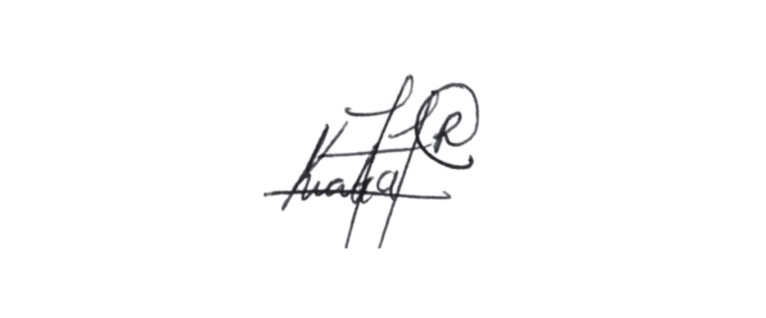
Date: 14/08/2026

